Tyler Butler

9/18/18

IT Analysis

Assignment 3

1. Read the case study on pages 91, 127, and 152 in the textbook.

2. Answer the two questions on page 91 with the following clarifications:

* + Include at least five events in question 1.
    - User wants to browse through resorts
    - User wants to book a trip
    - User wants to add or drop a student from group
    - User needs to be reminded of final payment requirements
    - User wants to check booking status
  + Include at least five use cases as part of your use case diagram

|  |  |
| --- | --- |
| Spring Breaks ‘R’ Us Booking Subsystem | |
| **Use Cases** | **Users/Actors** |
| Browse through resorts | Student/Customer |
| Book a Trip | Student/Customer |
| Add/Drop a user from group | Student/Customer |
| Final Payment Reminder | Customer Service Representative |
| Check Booking Status | Student/Customer |

      3. Write a fully developed use case called "Book a reservation" using the model template in Figure 5-2

|  |  |  |
| --- | --- | --- |
| **Use Case Name:** | Book a reservation | |
| **Scenario:** | Create online reservation | |
| **Triggering Event:** | Customer wants to book an online reservation | |
| **Brief Description:** | Online customer books a reservation by selecting a room to book, entering basic information and then following up with billing information and address. | |
| **Actors:** | Customer | |
| **Related Use Cases:** | Might be invoked by the ‘Book a Trip’ Use Case | |
| **Stakeholders:** | Accounting, Customer Service, Sales | |
| **Preconditions:** | Desired room must be available  Credit/Debit Authorization services must be available  Book a room subsystem must be available | |
| **Postconditions:** | Customer information must be saved  Room must be flagged as reserved  Credit/Debit authorization must be approved  Room must be saved to customer information | |
| **Flow of Activities:** | **Actor** | **System** |
|  | 1. Customer indicates desire to book a reservation and selects which room he/she would like 2. Customer enters in which room he/she would like to reserve 3. Customer enters in credit/debit card information | * 1. System displays rooms for booking   2. System prompts user to select a room to book   2.1 System inputs dates and room for the reservation   * 1. System prompts customer for payment information   2. System verifies authorization for credit/debit card   3. System associates selected room with customer information   4. System returns valid reservation details |
| **Exception conditions:** | 1.2 Room is not available for reserving  3.1 Credit/Debit information is not valid | |

      4. Develop a System Sequence Diagram (SSD) for booking a reservation using the model template in Figure 5-10. 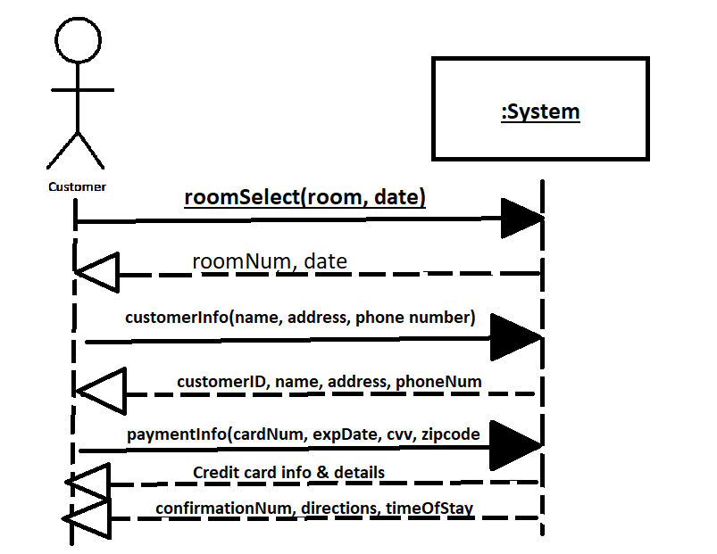

5. List at least three classes that are associated with a reservation in the domain model to understand the flow of activities and repetition involved.

